Thanks for helping support the 2022-2023 Ten Oaks Silver Fox Athletic Program! Your donation will help provide our student athletes with the tools they will need to be successful. Each donation goes directly towards helping outfit our athletes and Coaches with the safety and training equipment necessary to compete at a high level.

Sponsorship: Football/Basketball and Cheer Program /Garnetandsilver.com- $250.00

Business and/or Sponsor name will be announced at each HOME game (4 Football and 6 Basketball). Each Silver Fox supporter will also be displayed in the football program for each game and will be placed on the Home Page of "garnetandsilver.com" website.

Please attach business card or print name below as you wish it to appear in program and Web Site.
:

Donation: Donations to Silver Fox Athletic Program

Please choose a program above you would like your sponsorship to go directly to.

Name Amount $ Date

Please make all checks payable to Ten Oaks Middle School

Ten Oaks Silver Foxes Athletic Sponsor Receipt 2022- 2023

Name Amount $ Check # Received by Signed
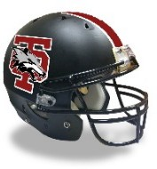
Date:
Thanks for all you do for Ten Oaks Athletics.
GO FOXES!

